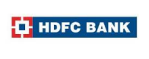 

Digital Marketing for HDFC Bank

University Name: Dr. B.R. Ambedkar Open University, Srikakulam.

Team Lead Member: Guruju Swapna

Member 1 (Name): Kaviti Pavani

Member 2 (Name): Kamelli Delleswari

Member 3 (Name): Guruju Saikumar

**Instructions**

1. Wherever the mention of, “Notes” is added you don’t need to add it on your slides. That’s just for your reference and information.
2. Please include the main header for each section. For example, Part 1 - Brand study, Competitor Analysis & Buyer’s/Audience’s Persona. Followed by your information that will be added by you.
3. When it comes to adding your files be it static image post can be added by inserting your picture file on the slide. The same can be done for videos. You can hyperlink these files. The instruction for the same is shared.
4. Apart from this you must 1 Folder for the projects and the other folders for each individual member of the group that’s assigned to you. Please upload the original files of images and videos of Instagram onto the project file as well by downloading it using any online tools.
5. Please try avoiding copying everything from AI. Try typing it down in your own words. Keep it simple, easy to read and original in most cases.
6. Once the project is done, please export the file as a PDF

**Part 1: Brand study, Competitor Analysis & Buyer’s/Audience’s Personas**

1. Bank Study

* Missions/values
* Unique Selling Proposition (USP)
* Brand and identity
* SMART goals and KPIs for Digital marketing of HDFC

2. Buyer’s/Audience’s Personas

3. Competitor Analysis

**1. Brand study**

**Mission & Values:**

HDFC's mission is to be a world-class Indian financial services institution, providing a wide range of financial products and services in a customer-centric manner. The mission underscores HDFC's commitment to excellence, innovation, and customer satisfaction in every aspect of its operations. Through this mission, HDFC aims to:

* **Serve Customers:** HDFC strives to meet the diverse financial needs of its customers by offering a comprehensive range of products and services tailored to their requirements.
* **Maintain Excellence:** HDFC is dedicated to maintaining high standards of excellence in all its endeavors, whether it's in customer service, product innovation, or operational efficiency.
* **Embrace Innovation:** HDFC emphasizes innovation to stay ahead in the dynamic financial services industry. It continually seeks new and improved ways to enhance its offerings, processes, and customer experiences.
* **Foster Trust:** HDFC values integrity and transparency in its interactions with customers, employees, and stakeholders. By upholding these principles, HDFC aims to build and maintain trust in the financial market.
* **Empower Communities:** HDFC recognizes its role in contributing to the economic growth and development of communities. It aims to empower individuals and businesses by providing them with financial tools and resources to achieve their goals.

**Unique Selling Proposition (USP):**

HDFC Bank's Unique Selling Proposition lies in its commitment to simplifying and digitizing the customer experience, offering a wide range of financial products tailored to individual needs, and maintaining a vast national presence to ensure accessibility and convenience for customers across India. By focusing on these key aspects, HDFC Bank continues to differentiate itself in the competitive banking industry and remains a preferred choice for millions of customers seeking reliable and innovative banking solutions.

**Brand and Identity**

HDFC's brand identity reflects its values, personality, and commitment to excellence in the financial services industry. Through a distinctive logo, consistent color scheme, clear typography, customer-centric tagline, and adherence to core values, HDFC establishes itself as a trusted, professional, empathetic, and innovative brand that prioritizes the needs and well-being of its customers. This cohesive brand identity strengthens HDFC's position in the market and fosters loyalty and trust among its diverse stakeholders.

**SMART Goals and KPIs:**

**1. Goal:** Increase Online Customer Acquisition by 15% in the Next Quarter

* **KPIs:**
* Number of new customers acquired through online channels
* Conversion rate of website visitors to new customers
* Percentage increase in online account openings compared to the previous quarter
* Time spent on the website per session

**2. Goal:** Improve Customer Engagement on Social Media Platforms

* **KPIs:**
* Social media engagement rate (likes, shares, comments)
* Increase in the number of followers/subscribers across social media channels
* Growth in reach and impressions of social media posts
* Click-through rate (CTR) on social media content

**3. Goal**: Enhance Mobile Banking App Usage and Adoption

* **KPIs:**
* Number of downloads/installations of the mobile banking app
* Active users and sessions per user on the mobile app
* Percentage increase in mobile app transactions (e.g., fund transfers, bill payments) compared to the previous quarter
* App store ratings and reviews

**4. Goal:** Reduce Customer Complaint Resolution Time by 20%

* **KPIs:**
* Average resolution time for customer complaints
* Customer satisfaction scores (CSAT) related to complaint resolution
* Number of escalations and unresolved complaints
* Improvement in Net Promoter Score (NPS) after implementing faster complaint resolution processes

**5. Goal:** Increase Cross-Selling and Upselling of Financial Products

* **KPIs:**
* Percentage increase in the number of customers availing multiple products/services
* Revenue generated from cross-selling and upselling activities
* Conversion rate of cross-selling offers to actual sales
* Customer feedback and satisfaction with recommended products/services

**6. Goal:** Enhance Employee Productivity and Satisfaction

* **KPIs:**
* Employee satisfaction survey results (e.g., engagement, morale, job satisfaction)
* Average handling time (AHT) for customer inquiries and support tickets
* Training completion rates and performance improvement metrics
* Employee turnover rate and retention

**7. Goal:** Improve Website Traffic Quality and Conversion Rate

* **KPIs:**
* Organic and paid website traffic metrics (visitors, sessions, page views)
* Bounce rate and average session duration
* Conversion rate of website visitors to leads or customers
* Search engine rankings for targeted keywords

**8. Goal:** Strengthen Brand Reputation and Trust

* **KPIs:**
* Net Promoter Score (NPS) and brand sentiment analysis
* Number of positive mentions and reviews on social media and review platforms
* Brand awareness and recall surveys
* Trust and credibility indicators (e.g., awards, certifications, partnerships)

**2. Buyer’s/Audience’s Persona**

**Target Audience:**

* **Urban Professionals:** Individuals working in urban areas seeking convenient and reliable banking solutions.
* **Middle to High-Income Families:** Families with stable incomes looking for investment opportunities, loans, and insurance products.
* **Young Millennials and Gen Z:** Tech-savvy individuals looking for digital banking solutions and investment options tailored to their needs.
* **Small Business Owners:** Entrepreneurs and small business owners in need of business banking services, loans, and financial advice.

**Persona Profiles:**

* Name: Riya
* the Urban Professional:
* Age: 30-35
* Occupation: Marketing Manager
* Needs: Convenient banking services, investment options, mortgage advice
* Name: Amit
* the Tech-Savvy Millennial:
* Age: 25-30
* Occupation: Software Developer
* Needs: Seamless digital banking experience, investment opportunities, mobile banking app with advanced features
* Name: Sunita
* the Small Business Owner:
* Age: 40-45
* Business: Boutique Owner
* Needs: Business banking services, loan options for expansion, merchant services

**3. Competitor Analysis**

**Key Competitors:**

* **ICICI Bank:** Known for its extensive branch network, diverse product offerings, and strong digital presence.
* **State Bank of India (SBI):** India's largest bank with a wide range of financial services and a strong foothold in both urban and rural areas.
* **Axis Bank:** Recognized for its innovative banking solutions and customer-centric approach.
* **Kotak Mahindra Bank:** Known for its focus on digital banking, wealth management, and innovative financial products.

**Points of Differentiation:**

HDFC's strong emphasis on customer service and personalized financial solutions sets it apart from competitors.

Its reputation for reliability and trustworthiness in the financial sector gives it a competitive edge.

HDFC's innovative digital banking services and user-friendly interfaces contribute to its differentiation in the market.

**1. ICICI Bank:**

**USP:**

* ICICI Bank's USP lies in its innovative digital banking solutions, extensive branch network, and diverse range of financial products and services.
* Online Communication:
* ICICI Bank employs a robust online communication strategy, leveraging social media platforms, email marketing, and targeted digital advertisements to engage with customers, promote its products, and provide customer support.

**Strengths:**

* Strong focus on technology and digital banking.
* Extensive branch network across India and globally.
* Diverse portfolio of financial products and services.
* Reputation for innovation and customer service excellence.

**Weaknesses:**

* Previous instances of controversies and regulatory issues.
* Intense competition in the banking sector.
* Dependency on technology for customer interactions may lead to service disruptions.

**Opportunities:**

* Growing demand for digital banking solutions.
* Expansion into new markets and customer segments.
* Partnerships with fintech companies to enhance service offerings.

**Threats:**

* Regulatory changes impacting banking operations.
* Cybersecurity threats and data breaches.
* Economic downturns affecting consumer spending and loan repayments.

**2. State Bank of India (SBI):**

**USP:**

* SBI's USP lies in its vast network of branches and ATMs, catering to the banking needs of diverse customer segments across urban and rural areas.
* Online Communication:
* SBI employs a multi-channel online communication strategy, utilizing its website, social media platforms, email newsletters, and mobile apps to connect with customers, provide updates, and offer support.

**Strengths:**

* Largest bank in India with a wide network of branches and ATMs.
* Strong brand recognition and trust among customers.
* Extensive range of financial products and services.
* Government backing and support.

**Weaknesses:**

* Bureaucratic structure leading to slow decision-making.
* Perception of poor customer service in some instances.
* Legacy systems hinder digital transformation efforts.

**Opportunities:**

* Expansion into international markets.
* Digitization and modernization of banking operations.
* Focus on financial inclusion and rural banking.

**Threats:**

* Competition from private and foreign banks.
* Regulatory changes impact profitability.
* The economic slowdown affects loan demand and asset quality.

**3. Axis Bank:**

**USP:**

* Axis Bank's USP lies in its focus on customer-centricity, innovative digital banking solutions, and personalized service offerings.

**Online Communication:**

* Axis Bank employs a targeted online communication strategy, utilizing social media platforms, email marketing, and mobile apps to engage with customers, provide educational content, and promote its products.

**Strengths:**

* Strong emphasis on customer service and satisfaction.
* Innovative digital banking platforms and mobile apps.
* Strategic partnerships with fintech companies for product innovation.
* Focus on retail and corporate banking segments.

**Weaknesses:**

* Relatively smaller branch network compared to competitors.
* Limited international presence compared to larger banks.
* Dependency on technology for service delivery.

**Opportunities:**

* Expansion into new markets and customer segments.
* Adoption of emerging technologies such as blockchain and AI.
* Partnerships with startups and fintech firms for innovation.

**Threats:**

* Intense competition in the banking sector.
* Regulatory changes impacting banking operations.
* Cybersecurity risks and data breaches.

**4. Kotak Mahindra Bank:**

**USP:**

* Kotak Mahindra Bank's USP lies in its focus on innovation, personalized service offerings, and strong corporate governance practices.

**Online Communication:**

* Kotak Mahindra Bank employs an integrated online communication strategy, leveraging its website, social media presence, email marketing, and mobile apps to engage with customers, provide updates, and offer support.

**Strengths:**

* Reputation for innovation and customer-centricity.
* Strong corporate governance and ethical practices.
* Diverse portfolio of financial products and services.
* Strategic acquisitions and partnerships for growth.

**Weaknesses:**

* Relatively smaller branch network compared to larger banks.
* Limited international presence compared to global banks.
* Dependency on technology for service delivery.

**Opportunities:**

* Expansion into new markets and customer segments.
* Embracing fintech partnerships for digital innovation.
* Focus on sustainable banking and ESG initiatives.

**Threats:**

* Intense competition from larger banks and fintech startups.
* Regulatory changes impacting profitability and operations.
* Economic downturns affecting loan demand and asset.

**Part 2: SEO & Keyword Research**

**SEO Audit:** Do an SEO audit of the brands website

**Keyword Research:** Define Research Objectives, Brainstorm Seed Keywords, Utilize Keyword Research Tools (SEMrush or Moz Keyword Explorer), Analyze Competitor Keywords, Long-tail Keyword Exploration (specific, longer phrases) that align with the research objectives and have lower competition but higher conversion potential.

**On page Optimization:** Meta Tag optimization & content optimization Reflect on the process of conducting keyword research and the SEO recommendations provided. Document the challenges faced during the research and analysis phase, as well as the key insights gained from the keyword research process.

**SEO (Search Engine Optimization)**

**1. On-Page SEO:**

This involves optimizing individual web pages to rank higher and earn more relevant traffic in search engines. Key factors include:

**Content Optimization:**

* Aim for content that is comprehensive, informative, and valuable to users.
* **Length:** While there's no magic number, longer-form content tends to perform better. Aim for at least 1,000 words for blog posts and articles.
* **Keyword Density:** Avoid keyword stuffing, aim for a natural distribution of keywords throughout the content.
* **Use of Multimedia:** Incorporate images, videos, infographics, and other multimedia elements to enhance user engagement.

**Meta Tags:**

* **Title Tags:** Keep title tags between 50-60 characters to ensure they display properly in search results.
* **Meta Descriptions:** Aim for meta descriptions between 150-160 characters to summarize the content effectively and encourage click-throughs.
* Headers (H1, H2, etc.): Use relevant keywords in headers to structure content and improve readability. Aim for one H1 tag per page and use H2-H6 tags as appropriate.

**URL Structure:**

* Keep URLs concise and descriptive, incorporating relevant keywords when possible.
* Avoid special characters, symbols, or unnecessary parameters in URLs.
* Use hyphens to separate words in URLs for readability.

**Internal Linking:**

* Aim to include 2-5 internal links per page, depending on the length and content.
* Use descriptive anchor text that accurately reflects the content of the linked page.
* Ensure a logical hierarchy of internal links to facilitate navigation and distribute link equity effectively.

**Page Speed Optimization:**

* Aim for a page load time of 2-3 seconds or less for optimal user experience.
* Use tools like Google Page Speed Insights or GT Metrix to identify and address speed-related issues.
* Optimize images, minify CSS and JavaScript, leverage browser caching, and utilize content delivery networks (CDNs) to improve page load times.

**Mobile Responsiveness:**

* Ensure that your website is fully responsive across various devices and screen sizes.
* Aim for a mobile-friendly design that prioritizes ease of navigation and readability on smaller screens.
* Test your website's mobile responsiveness using tools like Google's Mobile-Friendly Test.

**Off-Page SEO:**

This refers to actions taken outside of your own website to impact your rankings within search engine results pages (SERPs). Key strategies include:

* **Link Building:** Acquiring backlinks from reputable and relevant websites to demonstrate authority and relevance to search engines.
* **Social Media Engagement:** Sharing content on social media platforms to increase visibility and attract traffic.
* **Brand Mentions:** Getting mentioned or referenced by other websites or influencers, even without a backlink, can positively impact SEO.

**Technical SEO:**

This involves optimizing the technical aspects of a website to improve its search engine visibility. Key aspects include:

* **Crawlability and Indexability:** Ensuring search engine bots can access and index all relevant pages.
* **Site Structure:** Organizing website content in a logical and hierarchical manner.
* **Schema Markup:** Adding schema markup to help search engines understand the context of your content.
* **XML Sitemap:** Creating an XML sitemap to assist search engines in crawling and indexing your site.

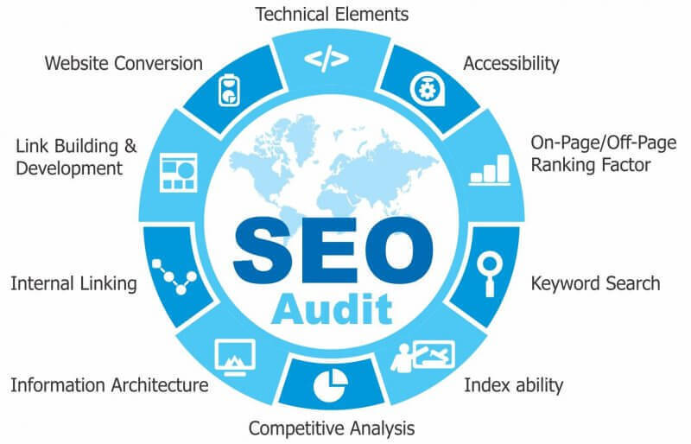

**Keyword Research**

* Start by researching keywords related to HDFC's digital marketing services, products, and industry. This may include terms like "HDFC digital marketing solutions," "HDFC online advertising," "HDFC social media marketing," etc.
* Use keyword research tools like Google Keyword Planner, SEMrush, or Arefs to identify relevant keywords with high search volume and low competition.
* Consider long-tail keywords that are specific to HDFC's offerings and services in the digital marketing domain.

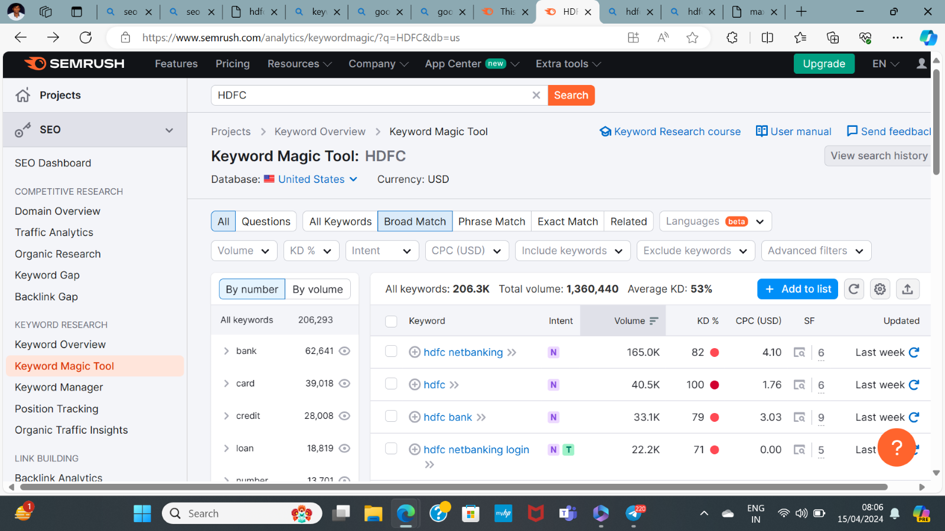

**Document the challenges faced during the research and analysis phase, as well as the key insights gained from the keyword research process.**

* Getting a free tool to do keyword research is a task since most tools are paid.
* Choosing the right keywords was an issue since there were a lot of relevant keywords in the list.
* We understood how the users search & gained insights into the kind of keywords people search for.

**Part 3: Content Ideas and Marketing Strategies**

Digital marketing for HDFC Bank can encompass a variety of strategies aimed at engaging existing customers, attracting new ones, and building brand awareness. Here are some content ideas and marketing strategies tailored for HDFC Bank:

* **Educational Content**: Create blog posts, videos, and infographics that educate consumers about various banking products and services offered by HDFC Bank, such as savings accounts, credit cards, loans, and investment options. Focus on explaining complex financial concepts in simple terms.

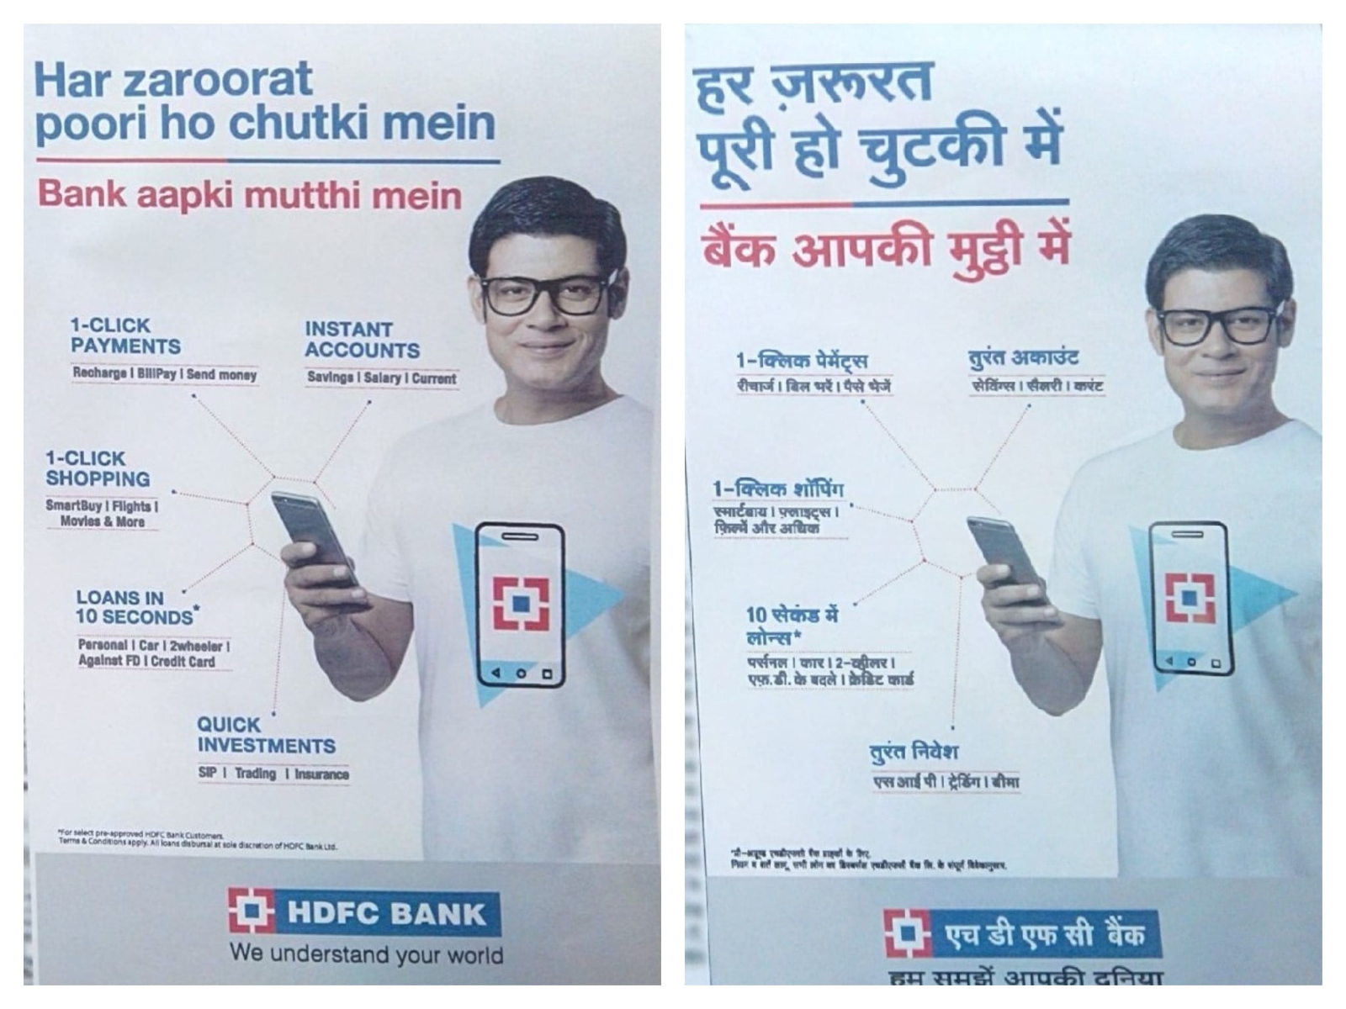

* **Personal Finance Tips:** Share practical tips and advice on personal finance management through social media posts, email newsletters, and blog articles. Topics could include budgeting, saving for retirement, managing debt, and smart spending habits.

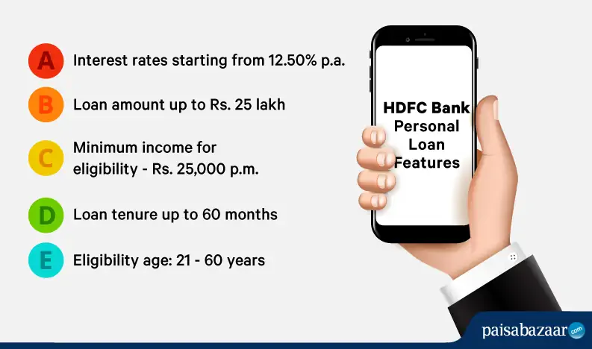

* **Customer Testimonials and Success Stories:** Feature real-life stories of HDFC Bank customers who have benefited from the bank's products and services. Testimonials can help build trust and credibility among potential customers.

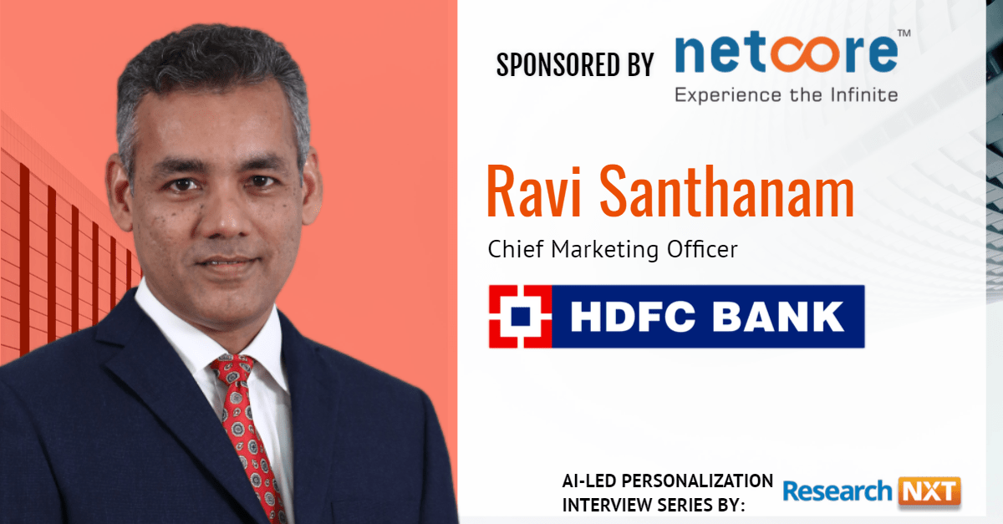

* **Interactive Tools and Calculators:** Develop online tools and calculators that help users estimate loan EMIs, savings goals, retirement planning, etc. These tools can provide value to consumers while subtly promoting HDFC Bank's offerings.

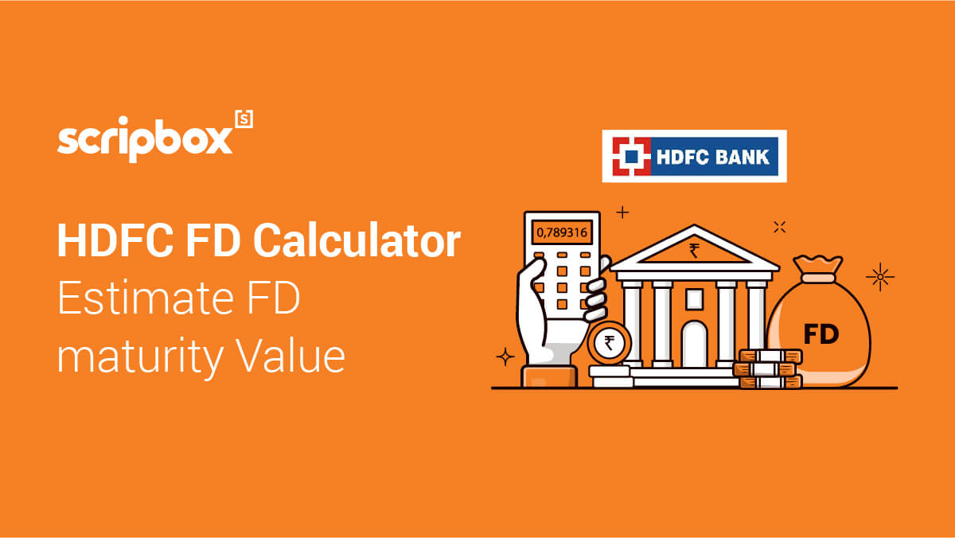

* **Social Media Campaigns:** Run engaging social media campaigns on platforms like Facebook, Instagram, Twitter, and LinkedIn. Incorporate interactive content formats such as polls, quizzes, and challenges to encourage user participation and increase brand visibility.

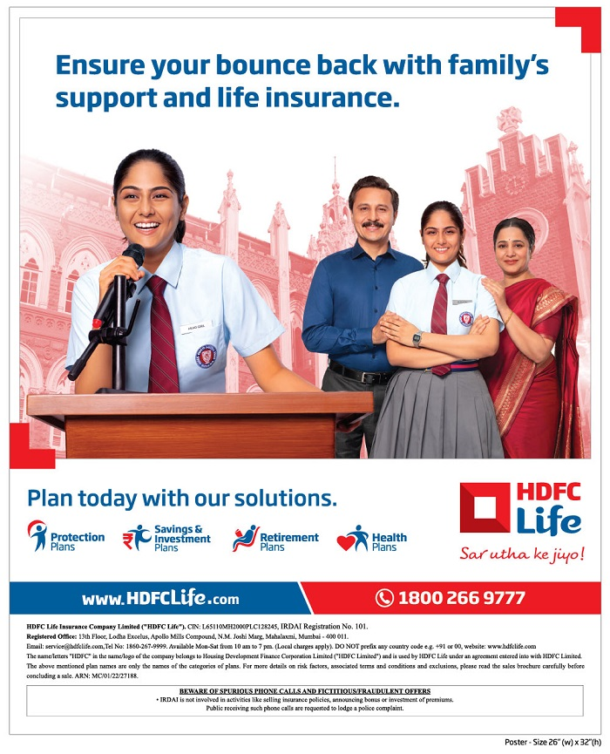

* **Email Marketing:** Utilize email marketing to nurture leads, promote new products/services, and share relevant financial tips and updates with subscribers. Personalize email content based on user preferences and past interactions with the bank.

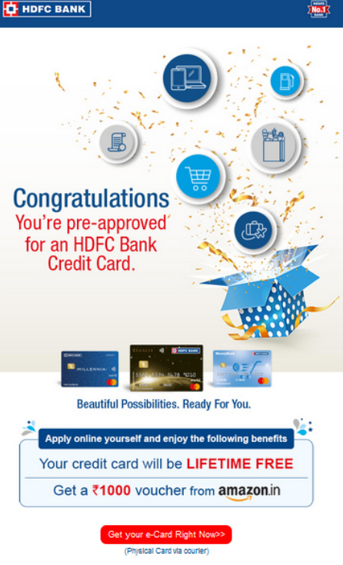

* **Search Engine Optimization (SEO):** Optimize HDFC Bank's website content for relevant keywords related to banking and financial services. Publish informative blog posts, FAQs, and resource pages to improve organic search visibility and attract targeted traffic.
* **Video Content:** Leverage the power of video marketing by creating tutorials, explainer videos, and customer testimonials. Host live Q&A sessions or webinars to engage with the audience in real-time and address their queries.

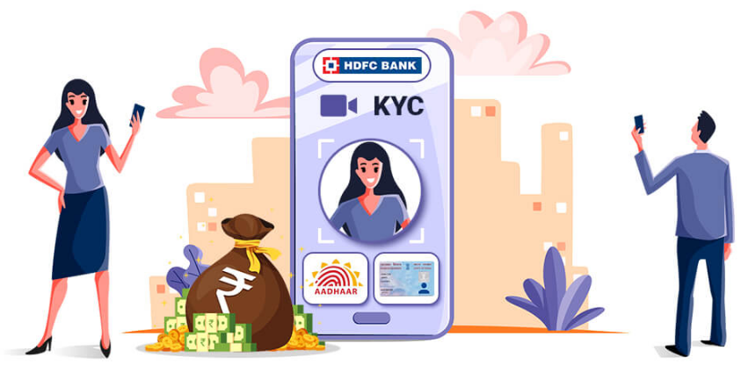

* **Partnerships and Collaborations:** Collaborate with influencers, financial experts, and industry influencers to reach a wider audience and tap into new market segments. Co-create content or sponsor relevant events to increase brand exposure.

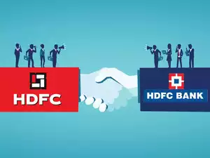

* **Mobile App Promotion:** Promote HDFC Bank's mobile banking app through targeted ads, app store optimization (ASO), and in-branch promotions. Highlight key features, security measures, and benefits of using the app for convenient banking on the go.

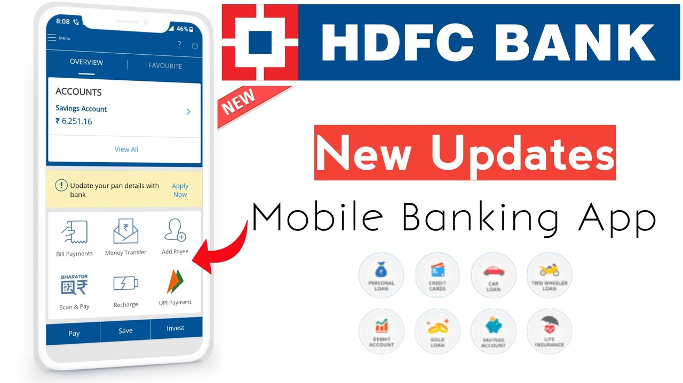

* **Community Engagement:** Participate in online forums, groups, and communities where users discuss finance-related topics. Provide helpful advice, answer questions, and share relevant content to position HDFC Bank as a trusted authority in the industry.

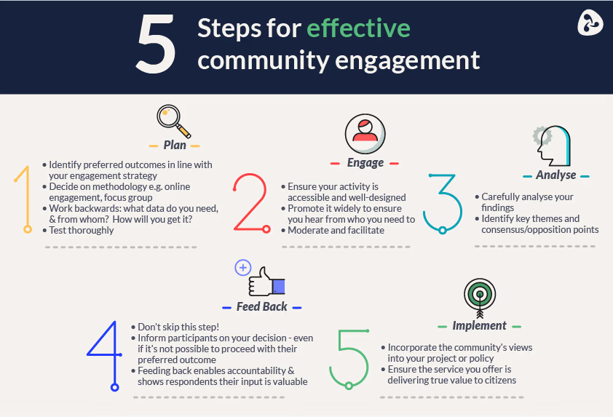

* **Data-driven Insights:** Analyze customer data and market trends to identify opportunities for personalized marketing campaigns. Use predictive analytics to anticipate customer needs and deliver targeted messages that resonate with their interests and preferences.

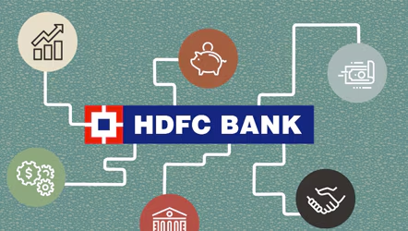 

**Part 4: Content Creation and Curation**

**HDFC Digital Marketing Post Ideas:**

Select Content Categories: Come up with three different content formats relevant to the chosen topic or industry. Research and Brainstorm: Research trending topics, industry news, or audience interests within each category. Brainstorm ideas for social media posts that align with each category. Write complete content/caption along with the CTAs.

**Content Category 1:** Informative & Educational

* Trending Topic: Rising interest rates & personal finance management
* Social Media Post Idea

**Headline:** Beat the Interest Rate Hike: Smart Money Management Tips!

**Caption:** Interest rates are on the rise! Don't worry, HDFC is here to help. Our latest blog post dives into practical tips for budgeting, saving, and managing your finances effectively during rising interest rates.

**CTA (Call to Action):** Click the link in bio to read the full blog post and get financially prepared! #HDFC #FinanceTips #InterestRates

**Content Category 2:** Engaging & Interactive

* Industry News: Growing popularity of mobile banking & digital payments
* Social Media Post Idea

**Headline: Quiz:** Are You Mobile Banking Savvy?

**Caption:** Test your knowledge on mobile banking and digital payments with our fun and quick quiz! Answer correctly and learn some handy tips along the way.

CTA: Take the quiz now and share your score in the comments! #HDFC #MobileBankingQuiz #DigitalPayments

**Content Category 3:** Promotional & Offer-Driven

* Audience Interest: Special deals & discounts on financial products
* Social Media Post Idea

**Headline:** Limited Time Offer! Get Extra Rewards on HDFC Credit Cards

**Caption:** Looking for ways to earn more rewards? Our exciting new offer lets you unlock extra cashback points on all your HDFC credit card purchases for the next month!

**CTA:** Don't miss out! Apply for an HDFC Credit Card today or visit the link in bio to learn more about the offer. #HDFCCreditCard #RewardsOffer #LimitedTime

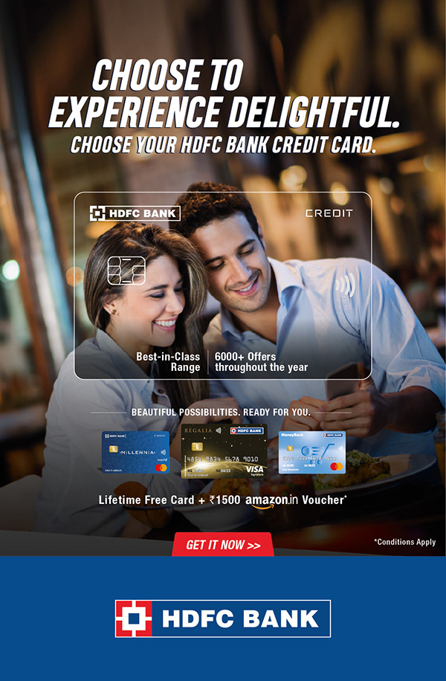

**Instagram Story**

###### Utilize the Stories feature on Instagram for two consecutive days. Share behind-the-scenes glimpses, polls, quizzes, or sneak peeks etc. to encourage audience participation. Once uploaded use the story highlight feature on Instagram and save these 2 stories with an appropriate name for each. Be as creative as possible.

###### **Note:**

###### Once done monitor the performance of the posts and Stories using the insight tool and analyze the engagement metrics (likes, comments, shares, impressions, etc.). Based on the analysis, mention the strategies and areas for improvement. Attach your screenshots (images of the story) and add your account link URL. Make sure your account is public

###### Screenshots of Story.

[**Instagram video by kavitipavani • Mar 6, 2024 at 12:06 PM**](https://www.instagram.com/reel/C4KVO4Mv6bw/?utm_source=ig_web_button_share_sheet)

[**HDFC Bank (@hdfcbank) • Instagram photos and videos**](https://www.instagram.com/hdfcbank/?igsh=MXJ1Z293eThtOHFyOA%3D%3D)

###### (Note: insert your dummy brand account link here)

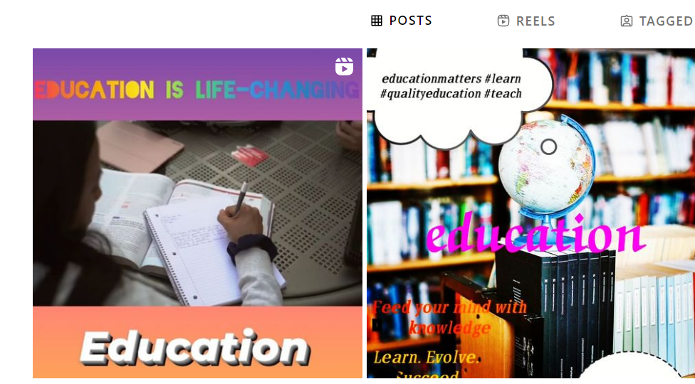

###### Highlights for Story.

[**Instagram photo by kavitipavani • Mar 4, 2024 at 8:40 PM**](https://www.instagram.com/p/C4GMz1qPJp1/?utm_source=ig_web_button_share_sheet)

[**HDFC Bank (@hdfcbank) • Instagram photos and videos**](https://www.instagram.com/hdfcbank/?igsh=MXJ1Z293eThtOHFyOA%3D%3D)

(Note: insert your dummy brand account link here)

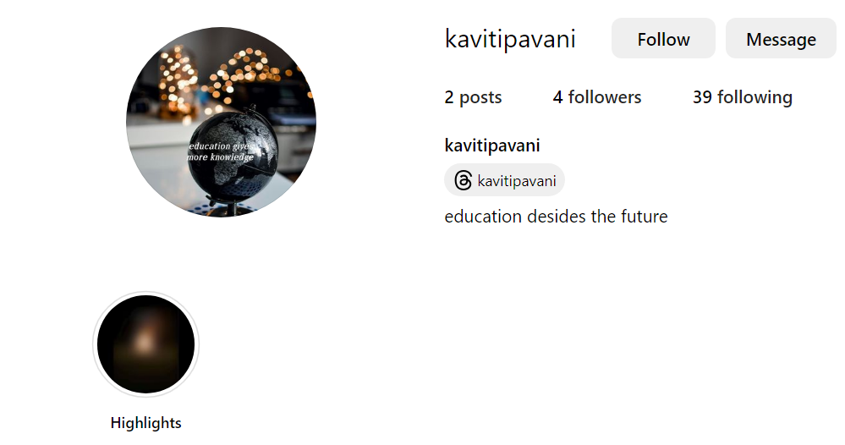

###### **Note:**

###### The account should be public so we can have a look at the highlights. Highlights are the green icons that you see on your account where you can save your stories to these highlights with appropriate names. Make sure to save two stories in separate story highlights. To add the highlight cover you can use Canva for designing it.

###### **Story Insights - Q&A**

###### **Note:**

###### You’ll have to individually go on each option under the insights feature to see where data is present and suggest areas for improvement. **Do this for the two stories posted on two days on each separate slid**e. Example is as under:

###### **Reach:** 323

###### **Impressions:**1042

###### Likes: 70

###### Etc.…

###### **Areas for improvement:**

###### 1) Story could be better. Quiz option would help in getting engagement

###### 2) Since the shares of informative stories are more, we could create more informative stories

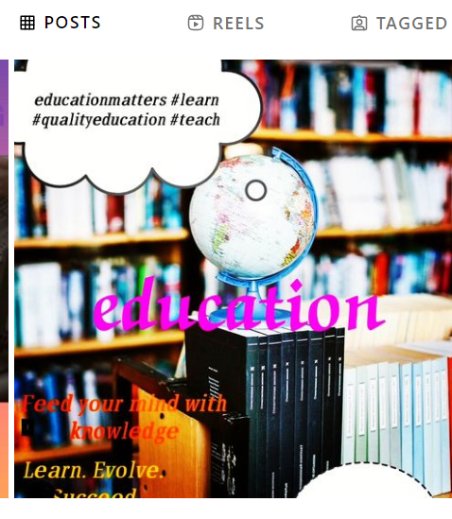

###### **Designs/Video Editing**

###### Design Tools Familiarization (use Canva for creating visually appealing graphics)

###### **Video Creation:** Utilize VN or any video editor of your choice to create videos related to the chosen topic.

###### **Note**:

###### This section is just a guide. You don’t need to do anything from here on. This is a preparation for you Format 1, 2 and 3 on the earlier slides. You can check the last two slides for additional information regarding how to design your creative and creating your reel.

###### Depending on the strategy planned on your content calendar, upload 3 posts/reels on your Instagram account.

###### For example, if you have uploaded a static image post like this. You can use <https://www.canva.com/> to create a very simple and attractive post. Make sure to bring out the message of your brand selected. Also include a caption and hashtag accordingly.

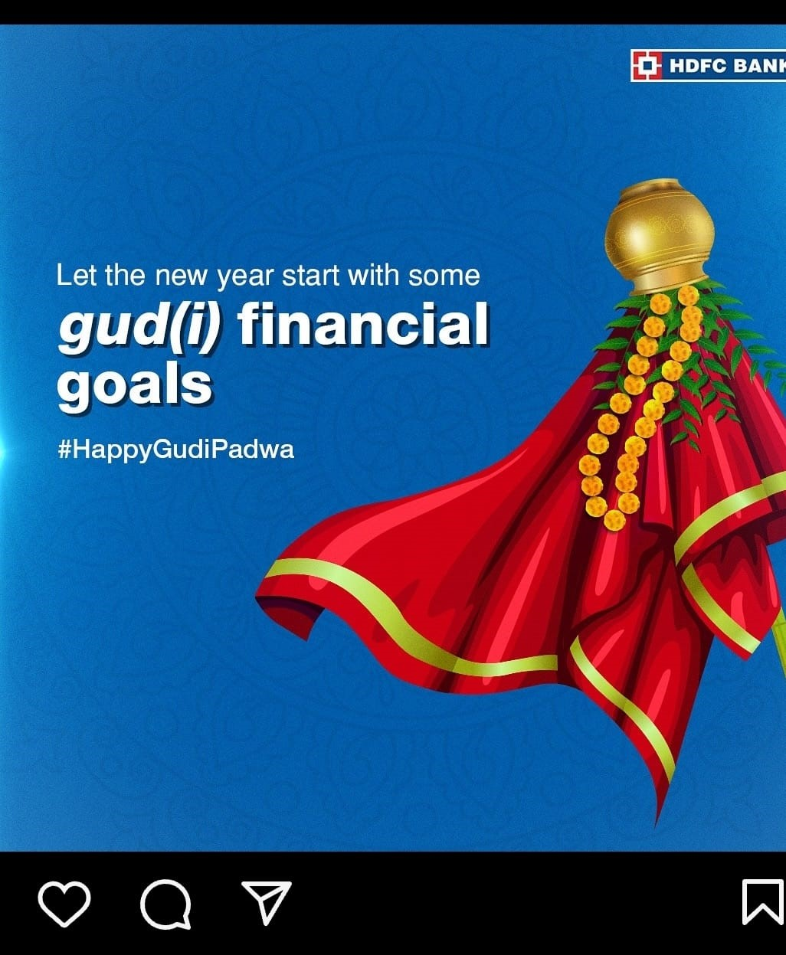

###### The more original and attractive the post is the better the marks will be. Please avoid copying or using posts already published by brands Similarly, when using video. Try to take the help of Canva or VN app in creating the videos. You can use stock videos from

<https://pixabay.com/videos/>

[**Free Stock Video Footage & Video Clips - Pixabay - Pixabay**](https://pixabay.com/videos/)

###### Note:

###### Click for your reference you can click on the image link to view the video.

###### The more original and attractive the reel is the better the marks will be. Please avoid copying or using videos already published by brands.